**Skewness and Kurtosis Report**

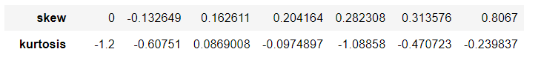

**Skewness:**

Skewness of ssc_p **: -0.132649**: Slightly negatively skewed (left-skewed).

Skewness of hsc_p: **0.162611**: Slightly positively skewed (right-skewed).

Skewness of degree_p **: 0.204164**: Slightly positively skewed.

Skewness of etest_p **: 0.282308**: Moderately positively skewed.

Skewness of mba_p **: 0.313576**: Moderately positively skewed.

Skewness of salary **: 0.8067**: Strongly positively skewed.

**Kurtosis:**

Kurtosis of ssc_p **:**  **-0.60751**: Platykurtic; the distribution has lighter tails and a flatter peak compared to a normal distribution.

Kurtosis of hsc_p: **0.0869008**: Close to mesokurtic; slightly heavier tails than a normal distribution, but not significantly.

Kurtosis of degree_p **: -0.0974897**: Platykurtic; slightly lighter tails and flatter peak.

Kurtosis of etest_p **: -1.08858**: Platykurtic; distribution is notably flatter with lighter tails.

Kurtosis of mba_p **: -0.470723**: Platykurtic; lighter tails and flatter peak.

Kurtosis of salary **: -0.239837**: Platykurtic; slightly lighter tails and flatter peak, though not extreme.

These are the overall report of Skewness and Kurtosis for this given Dataset.